Chapter 8, Solution 36.

Obtain v(t) and i(t) for t > 0 in the circuit in Fig. 8.84.

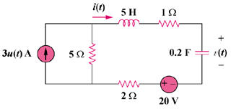

40 V

6u(t) A

Figure 8.84
For Prob. 8.36.

Solution

For t = 0–, 3u(t) = 0. Thus, i(0) = 0, and v(0) = 20 V.

For t > 0, we have the series RLC circuit shown below.

30V

+
−
+ −

10 Ω

i

0.2 F

+

v

−

10 Ω

2 Ω

40 V

5 H

- = R/(2L) = (2 + 5 + 1)/(2x5) = 0.8

ω_{o} = 1/ = 1/ = 1

s_{1,2} =

v(t) = V_{s} + [(Acos(0.6t) + Bsin(0.6t))e^{-0.8t}]

V_{s} = 30 + 40 = 70 V and v(0) = 40 = 70 + A or A = –30

i(0) = Cdv(0)/dt = 0

But dv/dt = [–0.8(Acos(0.6t) + Bsin(0.6t))e^{–0.8t}] + [0.6(–Asin(0.6t) + Bcos(0.6t))e^{–0.8t}]

- = dv(0)/dt = –0.8A + 0.6B which leads to B = 0.8x(–30)/0.6 = –40

v(t) = {70 – [(30cos(0.6t) + 40sin(0.6t))e^{–0.8t}]} V

i = Cdv/dt

= 0.2{[0.8(30cos(0.6t) + 40sin(0.6)t)e^{-0.8t}] + [0.6(30sin(0.6t) – 40cos(0.6t))e^{-0.8t}]}

i(t) = 10sin(0.6t)e^{-0.8t} A

